**ISS4014 – Database Systems and Web Integration**

**Chapter 06 – Activities and Homework**

Name: Logan Strong

Date: February 16th, 2024

**Chapter 06 REVIEW (10 points)**

1. When is a table in 3NF? (2 pts)

2NF and no transitive dependencies

1. When is a table in BCNF? (2 pts)

Every determinant is a candidate key

1. Given the dependency diagram shown below in Figure Q6.6, answer items 3a-3c:

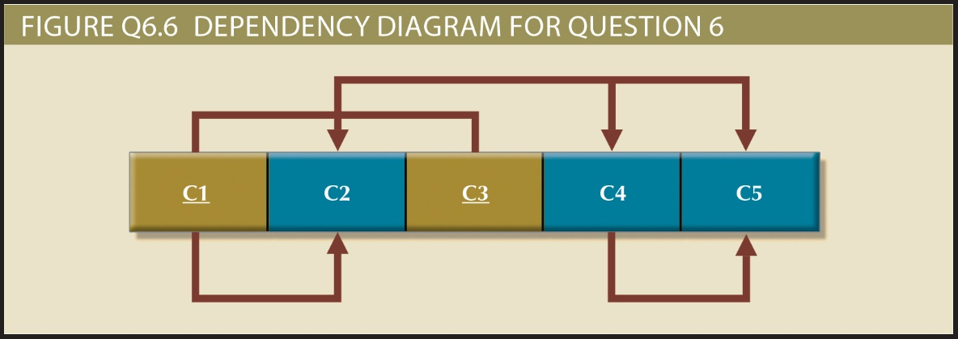

a. (2 pts) Identify and describe each of the indicated dependencies.

|  |  |  |  |
| --- | --- | --- | --- |
| ***Determinant***  ***(single or composite attributes)*** | ***Determines which attribute(s)…*** | ***Type of Dependency***  ***(full, partial, transitive)*** | ***Explain why you chose the dependency type*** |
| ***C***1, C3 | ***C2, C4, C5*** | ***full*** | ***Because C1 and C3 determine all other attributes in the diagram*** |
| ***C1*** | ***C2*** | ***Partial*** | ***Because C1 is part of a composite key and determines C2*** |
| ***C4*** | ***C5*** | ***transitive*** | ***B***ecause C4 is a determinate of C5, but C4 is not a prime key |

b. (2 pts) Using the Visio starter file found in canvas, modify this dependency diagram for this database, where the tables in 2NF, but not yet in 3NF, showing the dependency diagrams for each table. **Copy & paste the image from your VISIO diagram** into this assignment here:

***Paste dependency diagram(s) here.***



***NEXT, describe the dependency diagram(s) by filling in the following table:***

|  |  |  |  |  |  |  |
| --- | --- | --- | --- | --- | --- | --- |
| ***Table***  ***#*** | ***Normal***  ***Form*** | ***Schema*** | ***Primary***  ***Key(s)*** | ***Foreign***  ***Key(s)*** | ***Dependencies***  ***(e.g. Y1 > Y3, Y4)*** | ***Dependency Type for each***  ***Listed Dependency*** |
| ***1*** | ***3NF*** | *#1(****C1****, C2)* | ***C1*** | ***None*** | ***C1 > C2*** | ***Full*** |
| ***2*** | ***3NF*** | *#2(****C3****, C4, C5****)*** | ***C3*** | ***None*** | ***C3 > C4, C5*** | ***Full*** |
| ***3*** | ***2NF*** | *#3(****C1, C3,*** *C6)* | ***C1, C3*** | ***(In C6): C1, C3*** | ***C1, C3 > C6*** | ***Full andTransitive*** |

c. (2 pts) Using Visio, modify the dependency diagram for a database whose tables are at least in 3NF, showing the dependency diagrams for each table. **Copy & paste the image from your VISIO diagram** into this assignment here:

***Paste dependency diagram(s) here..***



***NEXT, describe the dependency diagram(s) by filling in the following table:***

|  |  |  |  |  |  |  |
| --- | --- | --- | --- | --- | --- | --- |
| ***Table***  ***#*** | ***Normal***  ***Form*** | ***Relational Schema***  ***(page 115)*** | ***Primary***  ***Key(s)*** | ***Foreign***  ***Key(s)*** | ***Dependencies***  ***(e.g. Y1 > Y3, Y4)*** | ***Dependency Type for each***  ***Listed Dependency*** |
| ***1*** | ***3NF*** | *#*1*(****C1****, C2)* | ***C1*** | ***None*** | ***C1 > C2*** | ***Full*** |
| ***2*** | ***3NF*** | *#*2*(****C3****, C4****)*** | ***C3*** | ***None*** | ***C3 > C4*** | ***Full*** |
| ***3*** | ***3NF*** | *#*3*(****C1, C3,*** *C6)* | ***C1, C3*** | ***(In C6): C1, C3*** | ***C1, C3 > C6*** | ***Full*** |
| ***4*** | ***3NF*** | *#4(****C4****, C5)* | ***C4*** | ***None*** | ***C4 > C5*** | ***Full*** |

**Chapter 06 PROBLEMS (20 points)**

(See the text for details for each question)

1. (3 pts) Using VISIO and the attributes given in the ERD in the figure below, convert the ERD into a 3NF dependency diagram.

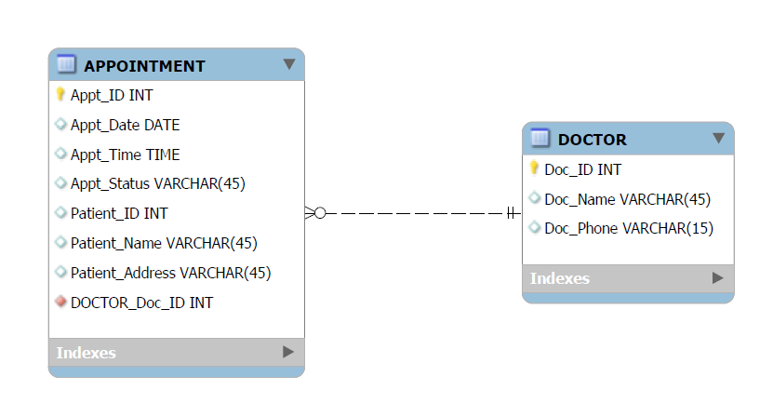

***Hints***:

1. First draw 2 dependency diagrams, 1 per entity (rectangles next to each other, 1 per attribute). **Use the Visio starter file found in Canvas**
2. Next, for each of the 2 dependency diagrams you drew, draw the fully functional dependency lines along the top of your dependency diagrams.
3. Next, identify and draw partial dependency lines if they exist, along the bottom of the dependency diagrams. These exist only when:
   1. There is a composite key in an entity
   2. AND when part of the composite key (1 of the attributes of a composite PK) determines 1 or more attributes.
4. Next, identify and draw transitive dependency lines if they exist, along the bottom of the dependency diagrams.
   1. These exist where one or more attributes can be determined by an attribute that is not part of the primary key.

***Paste your dependency Diagrams in 3NF here.***



1. (11 points total) Using the INVOICE table structure shown below…

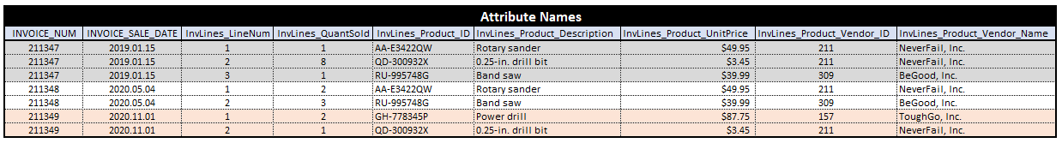

* 1. (3 pts) Draw its dependency diagram in 1NF which identifies all dependencies, including FULL, partial and transitive dependencies, and 2) write the relational schema which corresponds to the dependency diagram.

|  |
| --- |
| ***Hint #1***: INVOICE_NUM and InvLines_LineNum together form a composite primary key and determine all of the other attributes.   1. First draw the diagram (rectangles next to each other, 1 per attribute). **Use the Visio starter file found in Canvas**. 2. Next, draw the fully functional dependency lines along the top of your diagrams. 3. Next, identify and draw partial dependency lines if they exist, along the bottom of the dependency diagram. These exist only when:    1. There is a composite key in an entity    2. AND when part of the composite key (1 of the attributes of a composite PK) determines 1 or more attributes. 4. Next, identify and draw transitive dependency lines if they exist, along the bottom of the dependency diagrams.    1. These exist where one or more attributes can be determined by an attribute that is not part of the primary key. |

|  |
| --- |
| Dependency Diagram **with all dependencies labeled** (include all full, partial, transitive, if any) |
|  |

|  |
| --- |
| Relational Schema |
| Invoice (Invoice_Num, InvLines_LineNum, Invoice_Sale_Date, InvLines_QuantSold, InvLines_Product_ID, InvLines_Product_Description, InvLines_Product_UnitPrice, InvLines_Product_vendor_ID, InvLines_Product_Vendor_Name) |

* 1. (3 pts) Using Visio redraw the dependency diagrams with all **partial dependencies** removed so they are in at least 2NF (but still including any remaining transitive dependencies). Paste the redrawn image below. Next, 1) identify the normal forms for each table structure created and 2) write the new resulting relational schemas. Record your respond below.

|  |
| --- |
| Dependency Diagram with all dependencies (include all full and transitive, if any) |
|  |

|  |
| --- |
| Relational Schema |
| Invoice(Invoice_Num, Invoice_Sale_Date)  InvLines(InvLines_Num, InvLines_QuantSold, InvLines_Product_ID, InvLines_Product_Description, InvLines_Product_UnitPrice, InvLines_Product_vendor_ID, InvLines_Product_Vendor_Name) |

* 1. (3 pts) Using Visio redraw the dependency diagrams with all **transitive dependencies** removed so they are in at least 3NF. Paste the redrawn image below. Next, 1) identify the normal forms for each table structure created and 2) write the new resulting relational schemas. Record your respond below.

|  |
| --- |
| Dependency Diagram with all dependencies (include all full, partial, transitive, if any) |
|  |

|  |
| --- |
| Relational Schema |
| Invoice(Invoice_Num, Invoice_Sale_Date)  InvLines(InvLines_Num, InvLines_QuantSold)  InvLinesProduct(InvLines_Product_ID, InvLines_Product_Description, InvLines_Product_UnitPrice)  InvLines_Product_Vendor(InvLines_Product_vendor_ID, InvLines_Product_Vendor_Name) |

* 1. (2 pts) Using MySQL Workbench Designer or Visio, draw the Crow’s Foot ERD of the 3NF dependency diagrams and paste the image here. Be sure to indicate appropriate relationship strength and cardinality.

***Click or tap here to paste your ERD.***



1. (6 points total) Use VISIO to modify the initial dependency diagram shown below. **Use the Visio starter file found in Canvas**



1. (3 pts) Remove all **partial dependencies** so you can now 1) draw the new dependency diagrams which 1.a) still must include remaining transitive dependencies (if any) and 1.b) also identify the normal forms for each table structure you created with a textbook next to the table structure.

|  |
| --- |
| Dependency Diagrams with all dependencies (include all full, partial, transitive, if any) |
|  |

1. (3 pts) Remove all **transitive dependencies** so you can now, 1) draw the new dependency diagrams which identify the normal forms for each table structure you created.

|  |  |
| --- | --- |
| Dependency Diagrams with all dependencies (include all full, partial, transitive, if any) | |
|  |